Jerusalem Tour and one free day (2 DAYS / 01 NIGHT )
OVERVIEW :
Day 1: Amman – Border Crossing – Jerusalem: Mt of Olives & Old City Tour – West Jerusalem*
Day 2: Free Day in Jerusalem – Border Crossing – Amman
*time permitting

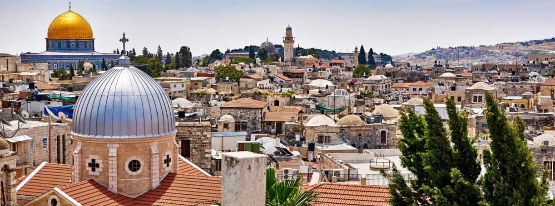
Tour Itinerary :
DAY 1: Amman – Border Crossing – Jerusalem: Mt of Olives & Old City Tour
Pick up from your door in Amman (or elsewhere in Jordan), and transfer to King Hussein / Allenby Bridge Israeli Terminal.
From the border crossing, drive to the Mount of Olives for a wonderful view over Jerusalem.
Continue to the Church of the Pater Noster, where the Lord’s Prayer is displayed on local-style pottery panels in over 100 different languages and dialects.
The traditional Palm Sunday route takes you then past the vast Jewish Cemetery and several other churches and monasteries. At the foot of the mountain, you can stroll through the Garden of Gethsemane with its beautiful ancient olive trees.
Enter the Old City through the Dung gate to visit the Wailing (or Western) Wall, and view the Haram Al Sharif with the Al-Aqsa Mosque and the Dome of the Rock.
Walk the Via Dolorosa with its Stations of the Cross till you arrive at the Church of the Holy Sepulchre, where Jesus was crucified and buried, and then rose again.
Take some time to explore the bazaars, and leave then the Old City to the west by Jaffa Gate. If time is permitting, you can drive through West Jerusalem and view various landmarks.
Overnight in Jerusalem.

DAY 2: Free Day in Jerusalem – Border Crossing – Amman
Spend another full day in Jerusalem. Explore the markets, shops, alleys, visit the many holy, cultural and historical sites, take some time to just sit and watch life happen around you, have a falafel sandwich, drink some tea,…
In the evening we will pick you up at a previously arranged location. Return to Allenby/ King Hussein Bridge, and from there to Amman (or elsewhere in Jordan), where we will drop you off at your preferred location.

Prices are per person, with all rates in US dollars, including all service charges and government taxes.
The standard accommodation will be in a twin or double room, and on Bed & Breakfast basis.
No. of Travelers | 3-Star Hotel | 4-Star Hotel | 5-Star Hotel
1* | $900* | $1,000* | $1,250*
2 | $500 | $550 | $700
3 | $430 | $500 | $650
4 | $380 | $420 | $600
5 | $350 | $400 | $530
6+ | $300 | $375 | $450
Prices may vary according to season, and are not valid during Christian or Jewish holidays.
*The additional cost for a single room is already included in the price for solo travelers.

✓ INCLUSIONS
  - Transport by an experienced driver in an air-conditioned vehicle.
  - Accommodation: 1 night in a Hotel in Jerusalem, twin or double room.
  - 1x Breakfast

☓ EXCLUSIONS
  - Entrances fees.
  - Exit tax out of Jordan.
  - Exit tax out of Israel / Palestine.
  - Transfers between border terminals & optional VIP Crossing Service.
  - All tips to guide & driver.
  - Everything not mentioned in the inclusions.

UPGRADES & ADDITIONS
If you want, you can stay in a single room, or add dinner – just let us know.
 | 3-Star Hotel | 4-Star Hotel | 5-Star Hotel
Single Room | +$50 | +$100 | +$115
Add Dinner | +$20 | +$40 | Not available

TOUR GUIDES
-We do our best to provide English-speaking, government-licensed guides whenever requested. Also guides speaking other languages might be a possibility. However, please note that especially during high seasons and holidays sufficiently qualified guides might not be available.
-The daily fee for a tour guide is approximately $500.

*Hotels to be used or similar for this tour (where the stay/overnight is applicable)***
Hotels Category | Jerusalem | Nazareth / Tiberias | Tel Aviv Hotel
3-Star Hotels | Jerusalem gate or Holy Land Hotel ( or similar*) | Astoria Hotel ( or Similar*) | Seanet Hotel or Similar*
4-Star Hotels | St George Hotel , The Olive Tree Hotel, the Grand Court Hotel ( or similar*) | Golan Hotel ( or similar*) | Grand Beach or Similar*
5-Star Hotels | Dan Jerusalem / the American Colony Boutique Hotel ( or *similar) | Leonardo Plaza Hotel ( or similar*) | Herods Tel Aviv or Similar*
*Please note that the hotels are subject to availability

Notes :
1- The Jordan Departure Taxt is 10 JD per person / $ 15 USD per person (SUBJECT TO CHANGE)
2- Exit tax out of Israel / Palestine is $ 56 USD per person (SUBJECT TO CHANGE)
3- Transfers between border terminals & optional VIP Crossing Service is $ 140 USD per person per way (SUBJECT TO CHANGE )
4-The guided tour option (English Speaking guide) , the guide costs $ 500 USD per day for all , this means that if you want to include the English speaking guide this costs for all of you $ 380 USD per day divided by number of travelers (i.e 500 / 2 travelers = $ 250 USD per person is the supplement for the guide and so on) , the rate $ 500 USD per day for all , for 02 days $ 500 x2 = $ 1000 USD and so on .) The other guided tours for other languages are upon request and subject to availability and the rate will be advised upon request and the rate might be more .
5-The above prices may vary according to season, and are not valid during Christian or Jewish holidays
6-Fridays and Saturdays border of Allenby closes by 12:00 hrs - 13.00 hrs, we should check your requested date in order to make sure that the tour works
7- Some nationality may require a visa to Israel to be arranged in advance.
8- On specific days, the borders may be closed and that should be checked with us

