01 Day Tour to Jerusalem from Amman / Madaba / Dead Sea (Sightseeing Tour to Jerusalem (01 day from Jordan ) Amman / Madaba / Dead Sea)
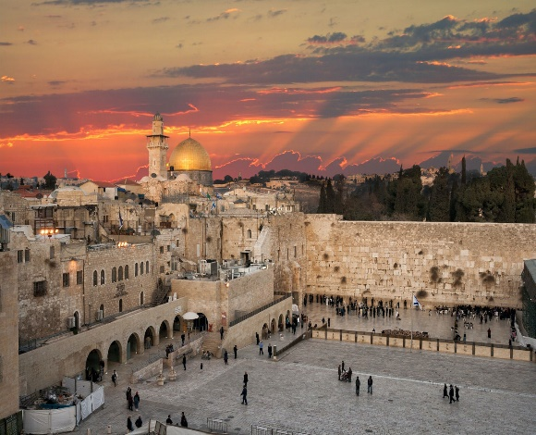 | Amman – Border Crossing – Jerusalem: Mt of Olives & Old City Tour – West Jerusalem* – Border Crossing – Amman  *Amman – Border Crossing – Jerusalem – Border Crossing – Amman  -Pick up from your door in Amman (or elsewhere in Jordan), and transfer to King Hussein / Allenby Bridge Israeli Terminal.  -From the border crossing, we will drive you directly to the Mount of Olives in Jerusalem for a wonderful view over the city.  -From there, continue to the Church of the Pater Noster, where the Lord’s Prayer is displayed on local-style pottery panels in over 100 different languages and dialects.  -The traditional Palm Sunday route takes you then past the vast Jewish Cemetery and several other churches and monasteries. At the foot of the mountain, you can wander through the Garden of Gethsemane with its beautiful ancient olive trees.  -Enter the Old City through the Dung gate to visit the Wailing (or Western) Wall, and view the Haram Al Sharif with the Al-Aqsa Mosque and the Dome of the Rock.  -Walk the Via Dolorosa with its Stations of the Cross till you arrive at the Church of the Holy Sepulchre, where Jesus was crucified and buried, and then rose again.  -Take some time to explore the bazaars, and leave the Old City to the west by Jaffa Gate. If time is permitting, you can drive through West Jerusalem and view various landmarks.  -Eventually return to Allenby/ King Hussein Bridge and from there to Amman (or elsewhere in Jordan), where we will drop you off at your preferred location.

Prices are per person, with all rates in US dollars, including all service charges and government taxes.
# of people | Tour Price |  | INCLUSIONS & EXCLUSIONS  ✓ INCLUSIONS:  -Transport to and from Jerusalem by an experienced driver in an air-conditioned vehicle.  -Transport between different sights in Jerusalem (please note that cars aren’t allowed to enter the Old City).  ☓ EXCLUSIONS:  -Entrances fees.  -Exit tax out of Jordan.  -Exit tax out of Israel / Palestine (SUBJECT TO CHANGE)  -Transfers between border terminals & optional VIP Crossing Service.  -All tips to guide & driver.  -Everything not mentioned in the inclusions.
 | DRIVER Only | GUIDE + DRIVER
1 | $590 | *See Tour Guides
2 | $310 | *See Tour Guides
3 | $220 | *See Tour Guides
4 | $180 | *See Tour Guides
5 | $160 | *See Tour Guides
6+ | $140 | *See Tour Guides
Notes :
1- The Jordan Departure Taxt is 10 JD per person / $ 15 USD per person (SUBJECT TO CHANGE )
2- Exit tax out of Israel / Palestine is $ 56 USD per person (SUBJECT TO CHANGE)
3- Transfers between border terminals & optional VIP Crossing Service is $ 140 USD per person per way (SUBJECT TO CHANGE )
4-The guided tour option (English Speaking guide) , the guide costs $ 500 USD per day for all , this means that if you want to include the English speaking guide this costs for all of you $ 380 USD per day divided by number of travelers (i.e 500 / 2 travelers = $ 250 USD per person is the supplement for the guide and so on) , the rate $ 500 USD per day for all , for 02 days $ 500 x2 = $ 1000 USD and so on .) The other guided tours for other languages are upon request and subject to availability and the rate will be advised upon request and the rate might be more .
5-The above prices may vary according to season, and are not valid during Christian or Jewish holidays
6-Fridays and Saturdays are not possible for this day tours as the border closes by 13.00 hrs

